Letterhead | Name, first name  Street  Zip code, city  E-Mail  Phone number
- Ideally one page
- Text size: 11 – 12 Pt.
- Font: Arial, Verdana or Trebuchet
- No spelling or grammatical errors!
- Clear style & structure

Address
Company
Your contact person (title if applicable)
Company address, street
Zip code, city

Place, current date
Aalen, 01.01.2023

Subject line (bold, followed by 2 blank lines): Clear reference to the job advertisement
"Your internship advertisement in the XY newspaper of ..." / Application as XY …
Avoid using standard phrases such as "As a skilled Mechanical Engineering student, I read your internship advertisement with great interest...”
Salutation and entry
Ask for a direct contact person!
Dear Ms. XY / Dear Mr. XY
- Introductory sentence with an individual "hook" that creates interest.

First paragraph
Why this COMPANY?

Describe the field of activity, place of work and employer, and motivation for the company.
Why ME?

Second and third paragraph
- Professional knowledge and experience (studies, internship, work experience) as well as personal skills and strengths (e.g., team spirit, ability to work under pressure, language skills, intercultural experience) concerning the advertised internship and the company.
Provide examples of situations in which you were able to demonstrate these qualities.
List the two or three most important arguments why you are the right person for the internship in this company and what distinguishes you from the other applicants.

Conclusion* and last paragraph
Formulate a desire for a personal interview.
E.g., "I would be very pleased to receive an invitation to a personal interview."

Greetings
Yours sincerely / Kind regards

Signature
If asked, please enclose officially translated copies of your most important and most recent transcripts with your application (e.g., work references, study certificates, etc.).
Attachments (certificates etc. as copy)

Resume ARYAN JADHAV

Personal Profile
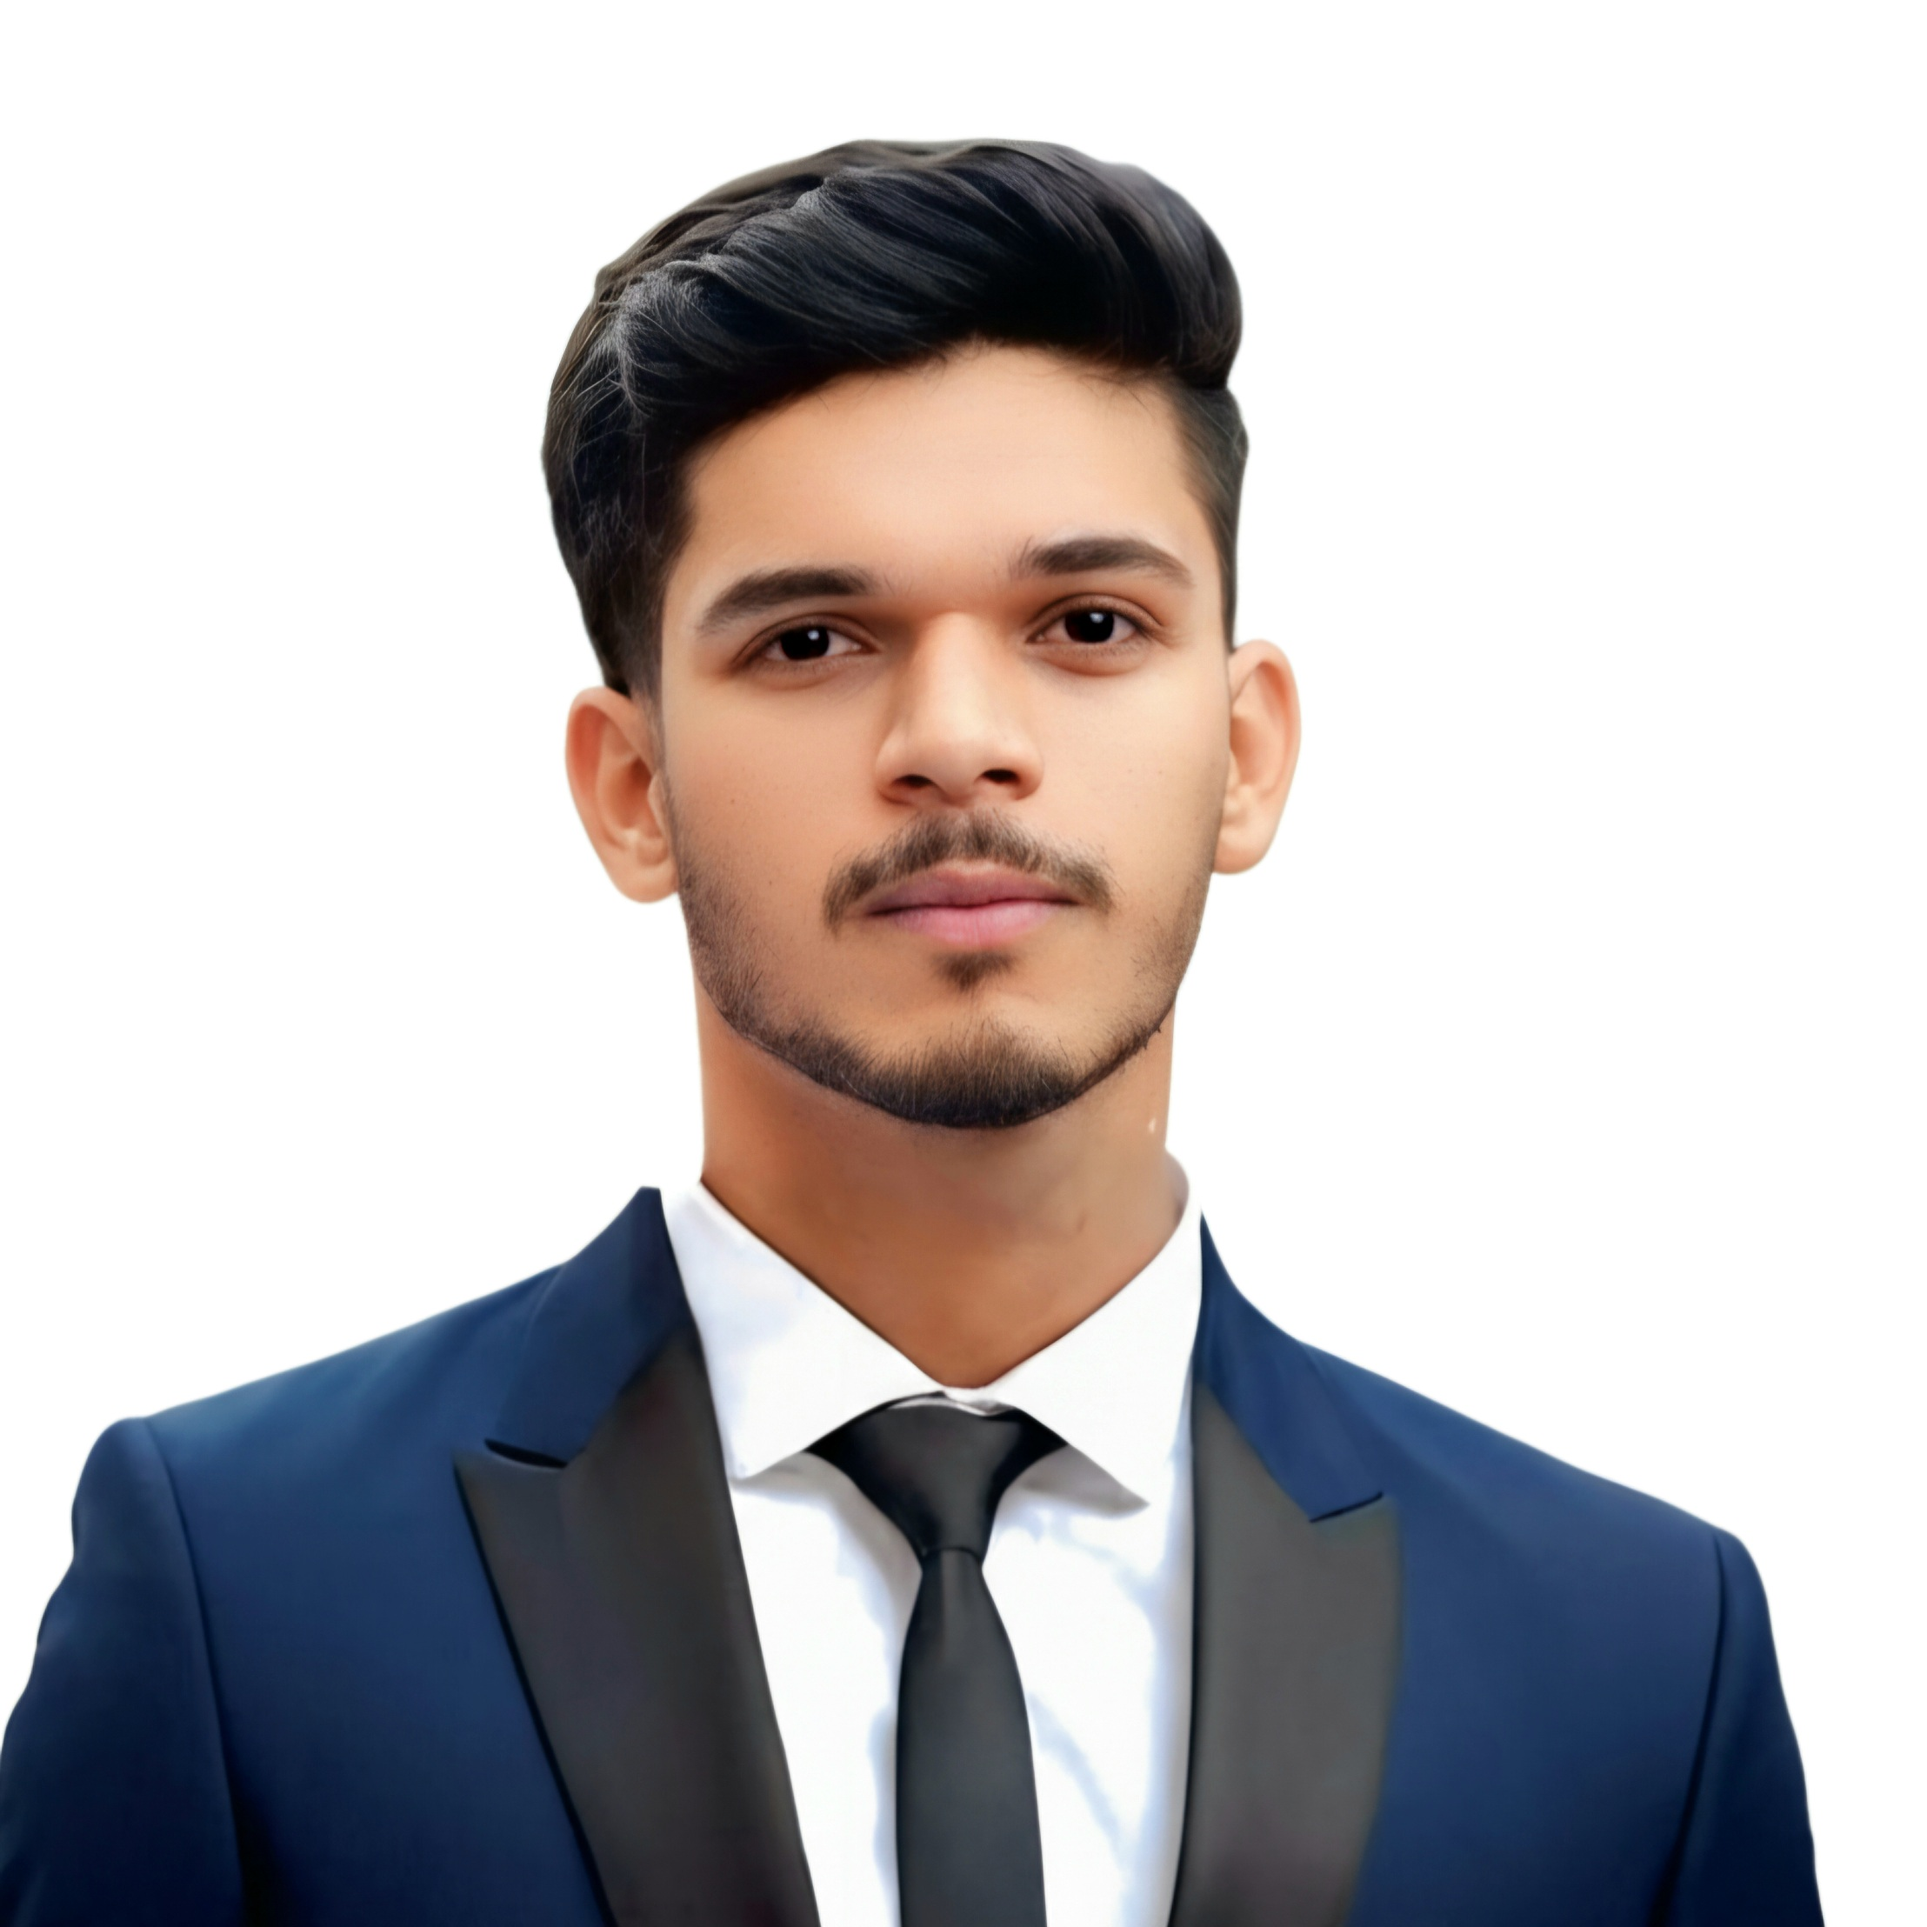
Address  Mobile  E-Mail  Date and place of birth  Work permit | Rombacher Strasse , 73430 Aalen  15511505418  aryanjadhav17112003@gmail.com  17.11.2003 in India  Unrestricted
Education and Studies / Academic Training
03/2026 – today  11/2021 – 08/2025  09/2008 - 07/2016 | Master of Science in Machine Learning & Data Analytics at Hochschule Aalen, Germany  - MLOps & Production AI  Bachelor of Engineering in Computer Engineering at the Pune University, India  - Machine Learning, Deep Learning, Pytorch & Python  - Suspicious Activity Detection from Surveillance Video  - Grade - 1.7  General qualification for university entrance at the SGM Maharashtra, India  - Mathematics, Physics, Chemistry, Biology  - Final grade – 1.5

Work Experience / Internships
8/2025 – 02/2026  08/2023 – 08/2024 | - Artificial Intelligence & Machine Learning Intern – Labmentix Pvt. Ltd., Bengaluru, India  - Data pre-processed and prepared datasets for Advanced machine learning models  - Developed, trained, and evaluated machine learning algorithms using Python  - Implemented AI-based solutions and supported in real-world project tasks  - Data Analyst – Core2Web, Pune, India  - Created and structured programming challenges with solutions for AI/ML topics  - Developed detailed explanations and documentation for coding problems  - Contributed to dataset creation and refinement for production-level applications

Other Activities such as Voluntary work / Further and Advanced Training Courses
11/2024 – 03/2026  09/2024 – Present | - German Language Instructor – Eduwrite Institute, India  - Taught basic German to school students (A1–A2 level)  - Matruchhaya Orphanage India  - Organized engagement events and awareness initiatives
(Special) Skills
Language skills  Computer skills | Hindi, Marathi  German  English  Microsoft Office  SAP | Native language  Intermediate knowledge (B1)  Advanced knowledge (C1)  Advanced knowledge  Good knowledge
Awards & Prizes
- 1. Rajya Puraskar Scout Award (Governor’s Award)
- Recognized for leadership, discipline, and community service in scouting

- 2. AAVISHIKAR 2023 – Savitribai Phule Pune University (Project Competition)
- Selected to represent University at State-level research competition

Interests / Hobbies / Activities
- Cricket  - Volleyball  - Art & Drawing | - competitive player; teamwork and leadership  - team sport; collaboration and coordination  - creative skills; technical sketching and painting

Place, date, signature (handwritten or digital)

